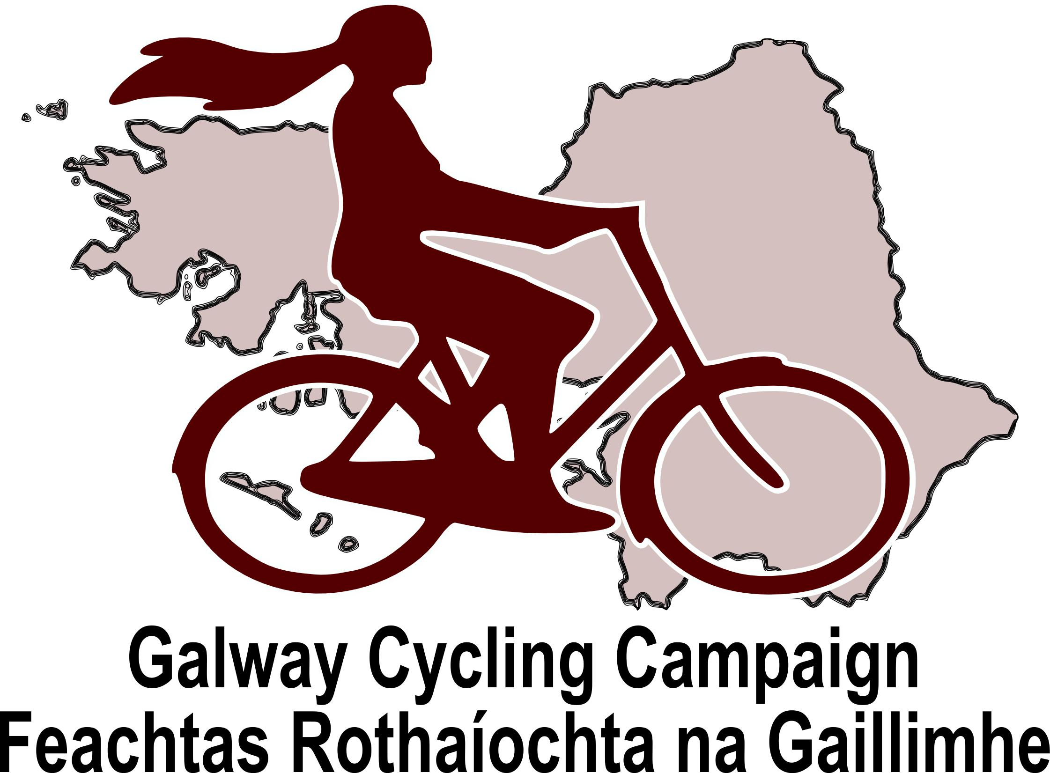
Speaking note for presentation to Oral Hearing on

Galway Harbour Extension

An Bord Pleanála Reference No> 61.PA0033

22 January 2015

Mr Inspector

We thank the board for holding this hearing on this important matter. We wish to address the hearing to expand on our previous observations under the following headings.

- Introduction: Description of Galway as a city. Current and potential cycling and walking participation.

- Statement of the problem: The impact of HGV traffic on the safety and amenity of roads for human beings eg cyclists and pedestrians.

- How the proposed development contributes to the problem.

- Concerns regarding the conduct of the EIS

- Our proposed solutions.

Introduction: Description of Galway as a city. Current and potential cycling and walking participation.

Galway is reasonably compact historic University city. It is a small city the population in 2011 was only 75,529. On paper, Galway could be ideal for cycling and walking. Census data from 2006 gives the following proportions for people living under 5km from work or education.

Children Aged 5 -12 60.5%
Students Aged 13 – 18 56.3%
Students Aged 19 and over 70.8%
Workers Aged 15 and over 44.7%

Five km equates to 20-25 minutes on a bicycle, within these numbers a significant number of people will also live within a reasonable walking distance of daily destinations. In the past, Galway was a “cycling city” and pockets of high cycling participation remain. (In 2006, Galway was the last city in Ireland where more secondary schoolgirls cycled than drove themselves to school.) According to 2011 census data, 4.63% of Galway residents cycled to work – the second highest rate in the country. Salthill, the Taylors Hill area and the Claddagh have the highest levels of cycling to work. In 2006, 9% of Salthill, 8% of Taylors Hill residents and 7% of Claddagh residents cycled to work or education.
In 2011 Galway had the highest levels of walking to work in the country at 15.96%. This is a fall from 19.96% in 2006 and shows that despite the economic downturn and sustained high fuel prices, walking continues to suffer the effects of poor public policies. There are pockets within the city - particularly in the area near the docks where more than half of residents walk to work.

Statement of the problem: The impact of HGV traffic on the safety and amenity of roads for human beings - cyclists and pedestrians.

Collision risk

It has long being recognised that Heavy Goods Vehicles creates serious safety issues for vulnerable road users. The government’s National Cycle Policy Framework (NCPF), 2009 sets out a “Hierarchy of Solutions” to be followed in creating a cycling (and by extension walking) friendly environment. In this hierarchy, reducing HGVs comes within the top measure.

“Measure 1: Traffic reduction

Can traffic levels be reduced, particularly heavy goods vehicles (HGVs). Measures could include restricting the movements of HGVs from local roads, building by-passes to divert through-traffic, and environmental road closures to discourage through-traffic.”

Elsewhere the National Cycle Policy Framework states:

“HGV Strategies
We will require local authorities to develop Heavy Goods Vehicle (HGV) Management Strategies for every town in the country. We will consider a ban on the movement of HGVs on routes to schools / other specific routes with mixed traffic between 08.30-09.30 and 15.00-17.00.”

Among the reasons for this emphasis on reducing HGV levels are that has long been recognised that HGVs are disproportionately involved in fatal collisions and in particular in fatal collisions involving cyclists. The presence of HGVs also results in a large reduction in the comfort and perceived safety of the shared roads environment for vulnerable road users. We provide a series of statements on the issue from various sources

- Dublin City Council have reported that of the 11 cycling fatalities that occurred in the city between 2002 – 2006, 8 of these deaths were of cyclists killed by left turning HGVs

A review of cycling deaths in London found as follows:
“HGVs were involved in 103 of 242 (43%) of all incidents and the vehicle was making a left turn in over half of these (53%).”

“HGVs are disproportionally involved in collisions fatal to cyclists: using the data from our study, freight vehicles are approximately 24 times more likely to be involved in a fatal incident than cars, 4 times as likely as buses and 8.5 times as likely as motorcycles.”

A UK National Cycling Charity (CTC) discussion document on Goods Vehicles provides the following observations.

“In urban areas, HGVs make up 2% of non-motorway traffic, and are involved in 24% of cyclists’ deaths.”

“In London specifically, where HGVs make up around 3.5% of traffic, almost half of the 44 cyclist fatalities between 2011-13 (inclusive) were as a result of a collision with a HGV. Of these 21, ten involved a collision with a left-turning HGV.”

“A cyclist is much more likely to die if they are in collision with a HGV than if they are in collision with a car: on average, cyclists are killed in around a fifth of serious injury collisions involving heavy goods vehicles, but in just over 2% of cyclist/car collisions.”

“Most collisions between cyclists and goods vehicles occur during lorry manoeuvres and/or at junctions. Roundabouts and left turns are a particular problem. In 2008 in London, 6 of 8 the fatalities that involved a lorry happened when it was changing lane to the left or turning left.”

Within collisions involving HGVs there is particular concern about the contribution of construction vehicles, particularly 4-axle tipper lorries. A 2013 Transport Research Laboratory Paper reviewed 16 fatal cycling collisions in London in 2011, 9 of these fatalities involved a goods vehicle and of these 7 were construction vehicles. In our view this is of particular concern with reference to the proposed works. It has been speculated that the over-representation of construction vehicle in cyclist deaths is due to both vehicle design issues and industry practices. One practice that is of concern is paying drivers by the load delivered rather than by hours worked.

Road Surface Issues and Cycling Safety

The city manager’s report on the proposals notes: “increase in the number of HGVs will result in the significant shortening of the lifespan of existing roads”. This damage inflicted on the road network by HGVs will impact on the safety of cyclists. A previous study on cycling accidents in Galway found that simple falls and collisions with roadside objects account for approximately 85% of injuries incurred while cycling (although mainly minor). The act of swerving to avoid potholes also becomes more fraught if there are simultaneously high numbers of HGVs present.

HGV Noise:

HGVs are loud, they are a source of engine noise and heavy exhaust fumes. The large axle loads create vibration which adds to the effect of the noise and the fumes. A chart given by the NRA document “Guidelines for the Treatment of Noise and Vibration in National Road Schemes 2014” gives a noise level of appx 85dB(A) for a heavy diesel lorry travelling at 40km/h and at a distance of 7m. Cyclists and pedestrians using the same roads as the construction traffic for this development may be as close as 1-3m to the HGVs. It must assumed that a proportion of the HGVs involved will be travelling at or above the stated limit of 50km/h within the city. A chart found in the EPA document “Guidance Note in Relation to Noise for Scheduled Activities” give 85db(A) as equivalent to a very busy pub where voices must be raised to be heard. We are assuming that on the streets of Galway this HGV noise will often be louder and be accompanied by vibration, exhaust fumes and wind generated by the vehicles passing. In our reading, we have not found any apparent discussion of this obvious impact on human beings in the EIS.

Contributing factors to the dangers posed by HGVs (Cycle facilities)

The strong association between cycling deaths and HGVs making left-turning movements makes it extremely difficult to see cycling facilities at junctions as a solution. Indeed cycling facilities that bring cyclists up the left hand side of HGVs at junctions have the potential to increase cycling fatalities. A 1993 German study found that HGVs are almost twice as involved in collision with cyclists at junctions with cycling facilities as at junctions without them. In the UK, cyclists have been killed or injured after getting trapped between pedestrian guard rails and HGVs, it is argued that such guard railing should be removed altogether. In order to bring the issue home I would like to read the following four names into the record.

- Maria Sonia Jimenez Martinez (aged 28). Suffered fatal injuries using a cycle-track at junction of Malahide Road and Griffith Avenue, Dublin 28/01/2004.
- Dante de Vere Padua (aged 32). Suffered fatal injuries using cycle-track at junction of East Wall Road and Annesley Bridge Road, Dublin 8/02/2005.
- Conor Murphy (aged 41). Suffered fatal injuries using cycle-track at Belgard Road, Dublin 30/05/2006
- Nadia Lescuier (aged 31). Suffered fatal injuries using cycle-track at Plassey Park Road, Limerick 18/10/2006.

All the deceased were crushed by turning HGVs while using cycle tracks

Conclusion on impacts of HGVs

Cycle facilities contribute to the dangers of HGVs. This is one of the reasons why the National Cycle Policy Framework and similar documents start with recommending HGV reduction before moving on to other measures, of which, cycle facilities come near the bottom of the list. There are other measures such as driver training, cyclists training, additional vehicle mounted blind-spot mirrors, mirrors mounted on traffic signals and so on. None of these measures alter the essential fact that HGVs are not compatible with roads of an urban character, roads that host a range of human activities as well as travel.

Therefore in creating a sustainable urban roads environment the over-riding aim must be to eliminate HGVs to the greatest extent possible.

How the proposed development contributes to the problem of HGVs in the city.

The development as proposed will result in an increase in HGV movements in Galway City during and after construction. The proposed development is clearly in fundamental opposition to the Government’s National Cycle Policy Framework.

Section 4.5.2.21 (Construction Machinery) of the EIS sets out predicted movements of heavy Construction Vehicles HCVs during construction. Including in Stage 1 - 300 HCV movements per day for 9 months, during Stage 2 – 100 HCV movements per day for 6 months, during Stage 3 100 HCV movements per day for 6 months. Figures given in Table 4.5.3 (Principle Quantities for Construction) suggest the movement of 1,114,650cu.m of material from local quarries through city roads that also function as cycling and walking routes and school routes. According to the Galway City Council manager’s report

“ on an average weekday there are 376 HGV movements on Lough Atalia Road. During the AM peak hour there were 41 HGV movements through the Lough Atalia / College Road junction and during the PM peak hour there were 15 HGV movements. During the operation of the development it is expected that there will be 40 HGV movements generated during the AM peak hour and 22 HGV movements during the PM peak hour. This equates to an increase of HGV movements of 102% and 147% during the AM and PM peak hour respectively. This potential increase in the number of HGVs will result in the significant shortening of the lifespan of existing roads.”

The values given in the manager’s report suggest 81 HGV movements in the AM peak and 37 in the PM peak.

Haulage routes

In the EIS, drawing 2139-2180 and chapter 13.4.5.3 describe the proposed haulage routes (HGV Routes) for construction material. The developers propose to bring construction material into the city from a range of directions passing through various city districts on the west, north-west, north-east and east. All this traffic then converges on Lough Atalia road. In our view the drawings are incomplete and misleading. On the north-west of the city, due to the banned right-turn at Newcastle, HGVs trying to leave the city via the N59 will have to use the Thomas Hynes road (the only other alternative is via the core of the city at Dominick St). This will involve using the roundabout adjacent to the University and the University hospital. Likewise the text of the EIS refers to Wellpark Road although this is not shown in the drawings. Wellpark road becomes Monivea Road and includes a school and a campus of GMIT.

We have identified the various places along the proposed haulage routes that are obvious destinations for vulnerable roads users. This makes these roads unsuitable as routes for heavy construction traffic:

East:
Monnenageisha GRETB School (Wellpark Road)
Colaiste na Coirbe (Cemetry Cross/R336)
Bohermore Cemetery
Eye Cinema/Wellpark Retail Park
GMIT (R338 Old Dublin Rd)
Bon Secour's Hospital
Holy Trinity and St Michaels National Schools (Mervue)
Gaelscoil Dara (Renmore)
Brothers of Charity Service (Wellpark)
St Francis National School - N84 (Headford Road)
Church of the Resurrection - N84 (Ballinfoyle)

Many of the children take the bus to school to and from Doughiska and cross the Dublin Road to Renmore

West
NUI, Galway -> Junction of N6/N59 - and all along the SQR/BOD
Shantalla National School (School Bhride) SQR
Galway Educate Together School - N59 (Thomas Hyne's Road)
St Joesph's Special National School - N59 (Thomas Hyne's Road)

Future HGV movements associated with the operation of the harbour.

In the EIS, section 13.3.3.3 (Proposed Freight Generated by Galway Harbour Development) states.

“It is predicted by 2035 that the proposed Galway harbour capacity will be increased to circa 1.932m tonnes per year, or approximately 5,300 tonnes per day. Thus, 9 No. 600 tonne payload freight trains per day for 365 days a year would be required to fully service the proposed freight requirement via rail alone. However we believe rail freight services will likely be a fraction of the new tonnage and specifically a newly won specific product.”

It would seem the even the consultants are of the view that the vast majority of freight distribution from the expanded harbour will continue to be by HGV. It seems the near future for a small university city will involve HGVs moving up to 5,300 tonnes of cargo a day on roads shared with children and adults walking and cycling to school or work. We find it incomprehensible that in 2015 any one would seriously suggest such a fate for a city like Galway.
Concerns regarding the conduct of the EIS

It is our understanding that conduct of the current Environmental Impact Statement Process (EIS) is governed by Article 4 in Schedule 6 of the Planning and Development Regulations, 2001 (S.I. No. 600/2001)

Article 94 states that the EIS is to contain,

“a description of the aspects of the environment likely to be significantly affected by the proposed development, including in particular:
human beings, fauna and flora,
soil, water, air, climatic factors and the landscape,
material assets, including the architectural and archaeological heritage, and the cultural heritage”

In our reading of the EIS we can find no adequate assessment, acknowledgement or analysis of the established safety issues thrown up by directing large numbers of HGVs through a small university city both during construction, and when the expanded harbour is in operation. Nor is there any apparent assessment of other impacts of such traffic such as the increased exposure of cyclists and pedestrians to the noise of heavy construction traffic in close proximity. There is detailed discussion of the effects of noise on fauna such as salmon, and marine mammals from cetaceans to grey seals. There is no apparent discussion of the effect of HGV noise, fumes or vibration on cyclists or pedestrians only a few metres away on the road or footpath.
Walking and cycling are not just forms of transport they are also part of how people see themselves, they are part of the cultural heritage of places. It is impossible to discuss cities like Amsterdam or Copenhagen without also referring to the cycling culture or the walking culture in the extensive pedestrian areas. Walking and cycling are also part of the cultural heritage of Galway. Through its promotion of HGV traffic in an urban realm it is clearly in opposition to this cultural heritage. This is not discussed in the EIS. It should not be forgotten that Galway has a significant tourism industry. In our view moves to push more HGV traffic into the city also represent a direct threat to the amenity and attractiveness of the city as a tourist destination.

The omission of these obvious impacts from the EIS clearly indicates that the EIS process was not carried out in a correct manner in accordance with the regulations. In our view these omissions may provide grounds on their own for the board to reject the EIS and the scheme in its current form.

Layout of Roads and Junctions

<Place holder for drawing based discussion>

Our proposed solutions.

A Galway Port ‘Tunnel’

The provision of the Dublin Port Tunnel and the associated city centre HGV ban is viewed has having transformed Dublin City Centre as a cycling and walking environment. The ban did not extend to 4-axle trucks but the collapse in construction activity during the downturn has achieved their removal. The lesson is the same – removing HGVs creates a better city. The lessons of Dublin need to be learned in Galway. (Dublin is not an isolated case HGV management has been a factor in creating attractive walking and cycling environments in other cities)

It is our view that if this development is to proceed a necessary prerequisite is the provision of an alternative road link serving the harbour. 1999 Galway County Borough Development Plan stated that there was a 30 metre reservation along the railway line through the Eastern residential suburbs. The 2005 Galway City Development Plan included a provision for a bus corridor following the railway line and coming in from the east of the city. This corridor is stated as a specific objective as under Section 3.5 and is shown in the maps. The development of this road, as already proposed by the city council, would provide an alternative route for construction traffic. When construction is complete this road would also provide a means for heavy freight traffic to avoid the city centre.

A HGV ban for the city centre and wider HGV management strategy will be necessary parts of a viable walking and cycling strategy for Galway. The provision of an alternative route for HGVs might also enable the development of a freight redistribution centre in the harbour area. This would allow goods brought to the city by HGV to be transferred to more suitable vehicles for final delivery. A new limited access road on this route would also improve the level of service for inter-urban buses.

If the scheme goes ahead it must be based on the provision of this dedicated route, constructed as a limited-access road, and serving the port. In addition measures must be taken to prevent construction traffic from using the city to get to this new road. In our view the easiest way to achieve this is to prohibit the use of quarries to the west or along the N84 and N17 corridors. Only quarries to the east with a clear access route that avoids the city should be used.

It should be a recognised principle that HGVs passing through the city to access the port is an unusual event to be avoided. To reinforce this, the proposed works at the Lough Atalia bridge should be dropped from the scheme as inappropriate. Likewise the revision of the existing harbour entrance to facilitate HGVs should be dropped from the scheme.

Summary

In summary it is our view that the proposals as currently conceived are demonstrably unsustainable and represent a threat to the safety and amenity of the city for walking and cycling. They also represent a threat to the cultural heritage of our city and to the attractiveness of the city as a tourist destination. We ask that the board reject the scheme in its current format.

Morgan A et al. Deaths of cyclists in London: trends from 1992 to 2006. Published in BMC Public Health. 2010.10:699.http://www.biomedcentral.com/content/pdf/1471-2458-10-699.pdf
CTE Briefing Note: Goods Vehicles, Briefing 4Q (December 2014)
Helman et. al Summary report: Construction logistics and cyclist safety, Project Report PPR640, Transport Research Laboratory 2013.
Brennan, M.J. (1979) Bicycle Travel in Galway City. RS 242, An Foras Forbartha.
Schnull R. and Alrutz D., Safety of Cyclists at Urban JunctionsReport 262, Bundesanstalt Fur StraBenwesen, 1993.
CTE Briefing Note: Goods Vehicles, Briefing 4Q (December 2014)

